COMMUNICATIONS TOOLKIT

Description: This toolkit includes optional template social media posts and an email you can use to help share the Research Roadmap and project findings.

ILLUSTRATION TO POST ON SOCIAL MEDIA OR SHARE VIA EMAIL

Optional description text: This illustration brings to life the key findings of our project, offering a powerful tool for the healthcare and research community to better understand the perspectives and priorities of both patients and primary care teams in addressing medical mistrust. We hope this illustration will be widely shared and utilized to help identify the most effective community-identified solutions and drive sustained efforts toward rebuilding trust and improving care for Black patients.
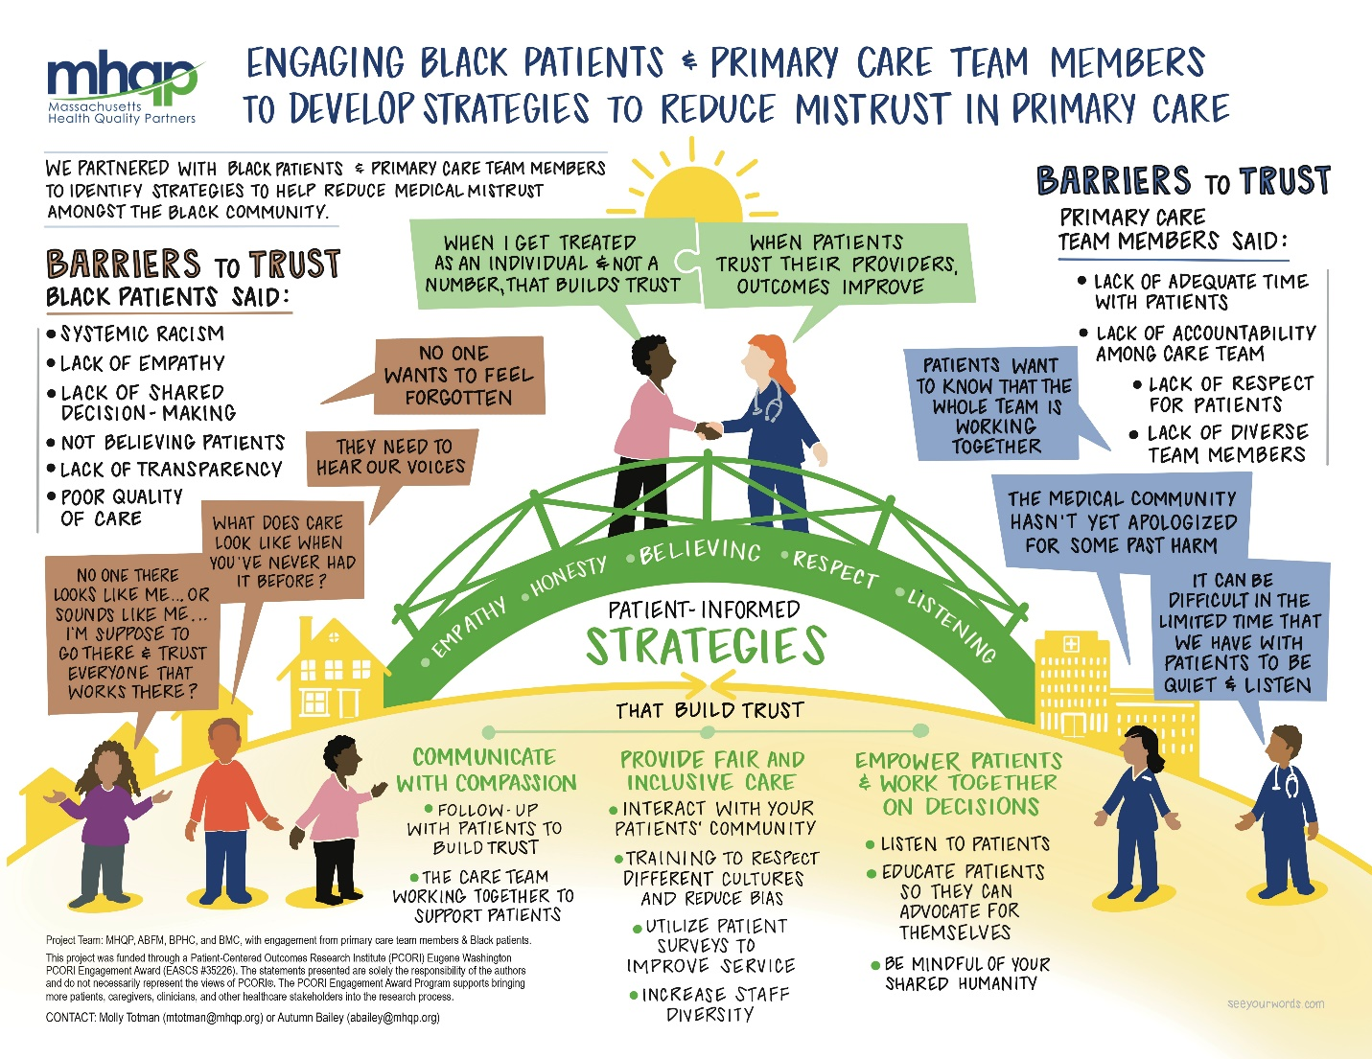

TEMPLATE SOCIAL MEDIA POSTS FOR LINKEDIN AND FACEBOOK

EXAMPLE POST #1

📢@MassachusettsHealthQualityPartners, @AmericanBoardofFamilyMedicine, @BostonPublicHealthCommission and @BostonMedicalCenter teamed up with community partners to create a Patient-Centered Research Roadmap, to develop strategies focused on reducing medical mistrust for Black patients in primary care.

This project was funded through a Patient-Centered Outcomes Research Institute (PCORI) Eugene Washington PCORI Engagement Award (EASCS #35226). The statements presented are solely the responsibility of the authors and do not necessarily represent the views of PCORI®. The PCORI Engagement Award Program supports bringing more patients, caregivers, clinicians, and other healthcare stakeholders into the research process.

Learn more and download the Roadmap here: https://www.mhqp.org/wp-content/uploads/2025/05/Engaging-Black-Patients-and-Primary-Care-Team-Members-in-Developing-Patient-Centered-Research-to-Reduce-Mistrust-in-Healthcare.pdf

#PatientCenteredResearch #Medical Mistrust #HealthEquity #Primary Care #CommunityEngagement

EXAMPLE POST #2

💬 “How can people do things without us [patients] and then [say] it's for us? …that just doesn't make any sense…. if you want to talk about how BIPOC communities begin to build trust with the medical profession, how can you do that without hearing their voices? “(Black/African American Patient).”

This is one of the many voices shaping the @MassachusettsHealthQualityPartners, @AmericanBoardofFamilyMedicine, @Boston Public Health Commission and @Boston Medical Center Research Roadmap aimed at developing strategies for reducing medical mistrust amongst Black patients.

This project was funded through a Patient-Centered Outcomes Research Institute (PCORI) Eugene Washington PCORI Engagement Award (EASCS #35226). The statements presented are solely the responsibility of the authors and do not necessarily represent the views of PCORI®. The PCORI Engagement Award Program supports bringing more patients, caregivers, clinicians, and other healthcare stakeholders into the research process.

Read more about what we heard and download the Roadmap here: https://www.mhqp.org/wp-content/uploads/2025/05/Engaging-Black-Patients-and-Primary-Care-Team-Members-in-Developing-Patient-Centered-Research-to-Reduce-Mistrust-in-Healthcare.pdf

#Primarycare #PatientCenteredResearch #HealthEquity #Communityengagement

EXAMPLE POST #4

💬 “Healthcare should really be a partnership and you can be super limited in your ability to care for a patient or care for a community if there is no trust (Family Medicine Physician)

This is one of the many voices shaping the @MassachusettsHealthQualityPartners, @AmericanBoardofFamilyMedicine, @Boston Public Health Commission and @Boston Medical Center Research Roadmap aimed at developing strategies for reducing medical mistrust amongst Black patients.

This project was funded through a Patient-Centered Outcomes Research Institute (PCORI) Eugene Washington PCORI Engagement Award (EASCS #35226). The statements presented are solely the responsibility of the authors and do not necessarily represent the views of PCORI®. The PCORI Engagement Award Program supports bringing more patients, caregivers, clinicians, and other healthcare stakeholders into the research process.

Read more about what we heard and download the Roadmap here: https://www.mhqp.org/wp-content/uploads/2025/05/Engaging-Black-Patients-and-Primary-Care-Team-Members-in-Developing-Patient-Centered-Research-to-Reduce-Mistrust-in-Healthcare.pdf

#Primarycare #PatientCenteredResearch #HealthEquity #Communityengagement

TEMPLATE EMAIL TO SHARE THE ROADMAP

Subject: Introducing a Research Roadmap to Reduce Mistrust in Healthcare Amongst Black Patients

Dear [Recipient's Name],

I am pleased to share that Massachusetts Health Quality Partners (MHQP), Boston Medical Center (BMC), the Boston Public Health Commission (BPHC), and the American Board of Family Medicine (ABFM) have collaborated to develop a Patient-Centered Research Roadmap focused on strategies to reduce medical mistrust amongst Black patients (see Roadmap attached). This initiative reflects input from key stakeholders, including patients, and members of the primary care team (E.g. clinicians, administrative support staff, and patient navigators)

This work was supported by the Patient-Centered Outcomes Research Institute (PCORI) through its Eugene Washington PCORI Engagement Award Program (EASCS #35266). The goal of this program is to bring patients, caregivers, clinicians, and other healthcare stakeholders into the research process to ensure that future studies are both relevant and impactful.

Given the long-standing challenges of addressing medical mistrust, the project team’s goal is to share this Roadmap widely, so that it can be used as a springboard for future research.

Should you have any questions or wish to discuss the Roadmap further, please feel free to contact
Molly Totman at mtotman@mhqp.org or Autumn Bailey at abailey@mhqp.org
Best regards,
[Your Name]

